INHEALTHCARE DESKTOP APPLICATION -
INTEGRATION WITH EMIS WEB
Document Control
Title | IHDA – EMIS Integration
Originator / Author | River Grant
Reviewer | Product Development
Business Area | Professional Services
Review Cycle | Annual and in accordance with updates to the software
Document Location | Confluence

Change Record
Version | Date | List Changes made to document | Document Status
1.0 | 15th October 2021 | New Document | Live

Document Ownership
Intechnology plc’s Professional Services Team is the owner of this document and is therefore responsible for ensuring that this guide is reviewed in line with updates to the Inhealthcare software.

Contents
Contents
Configuring EMIS Web 4
Purpose of Inhealthcare Desktop Application (IHDA) 4
EMIS Firewall Requirements 4
EMIS Configuration 4

Configuring EMIS Web

Purpose of Inhealthcare Desktop Application (IHDA)
The Inhealthcare Desktop Application integrates to allow the referral of patients from EMIS Web to Inhealthcare, this creates the patient record in Inhealthcare. This saves the user time in adding patient demographics and allows patient information to be uploaded back into EMIS Web.

EMIS Firewall Requirements
For the EMIS Web integration to work with the IHDA, it may be necessary to make Firewall changes within your network. This is to allow the local EMIS Web to communicate with the hosted EMIS Web servers.

The following ports may need to be opened to allow communication to EMIS (IP: 127.0.0.1) if they are not already open:

- UDP 8080
- UDP 8089
- UDP 8090
- UDP 8091
- UDP 8092

EMIS Configuration
The next step is to configure EMIS to allow integration with Inhealthcare. NB: this requires the appropriate access rights, usually restricted to senior practice staff or IT Teams.
- Launch EMIS Web and then click on the EMIS button in the top left corner. Click the EMIS button at the top left corner and click on System Tools > EMAS Manager
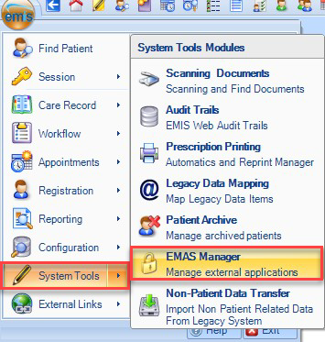
- From the EMAS manager select Partner API from the bottom left corner, then scroll and click to select Inhealthcare:
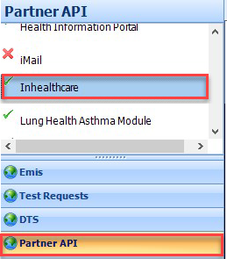
- With Inhealthcare highlighted, select Edit Users:
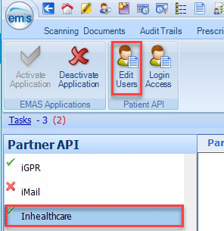
- Select all the users that will require access to the IHDA, click OK. API users do not gain any additional access to the EMIS Web client itself, but are able to use any Partner product which connects to it.
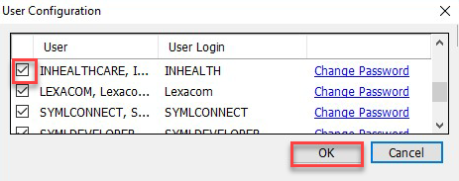
Setting an API password for each user is mandatory, but the password is only ever requested in the event that the Partner product is unable to automatically login to the API. Please check with the Partner to see if this is the case. Click OK to save changes.
- With Inhealthcare highlighted in the list of Partner APIs, click Activate Application.
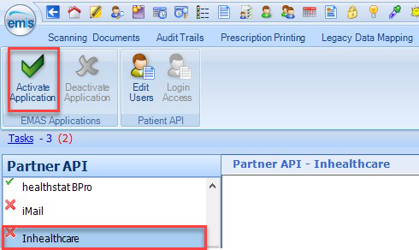
Inhealthcare will now show a green tick, confirming it is activated:
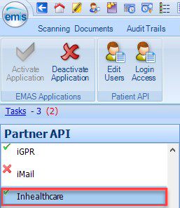
- Click on Login Access and then tick Auto Login and Allow Login against each user to ensure the IHDA works correctly for each user.
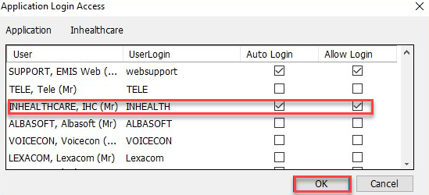
Click OK to finish the process.

